Nama : M Riziq Sirfatullah Alfarizi

Nim : i.2211266

1. Halaman **index.php**

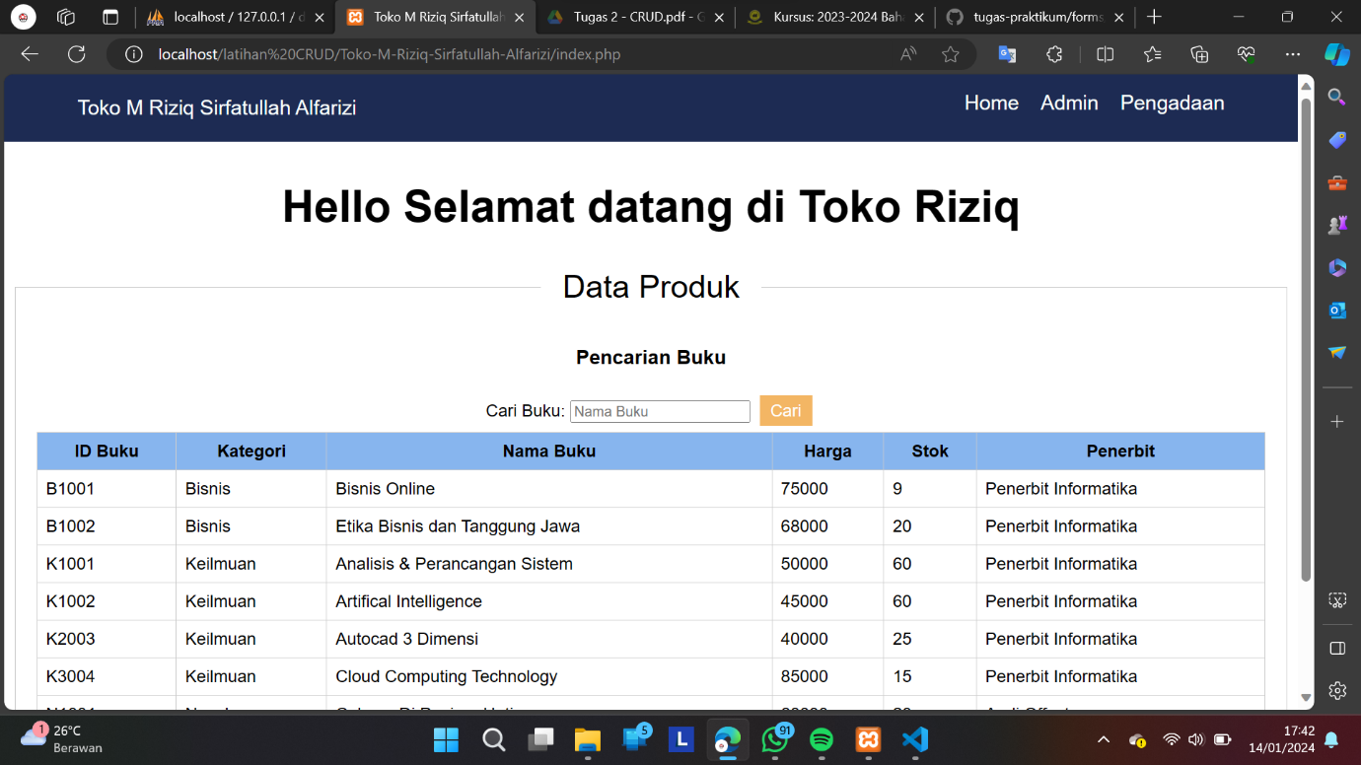

1. Halaman **admin.php**

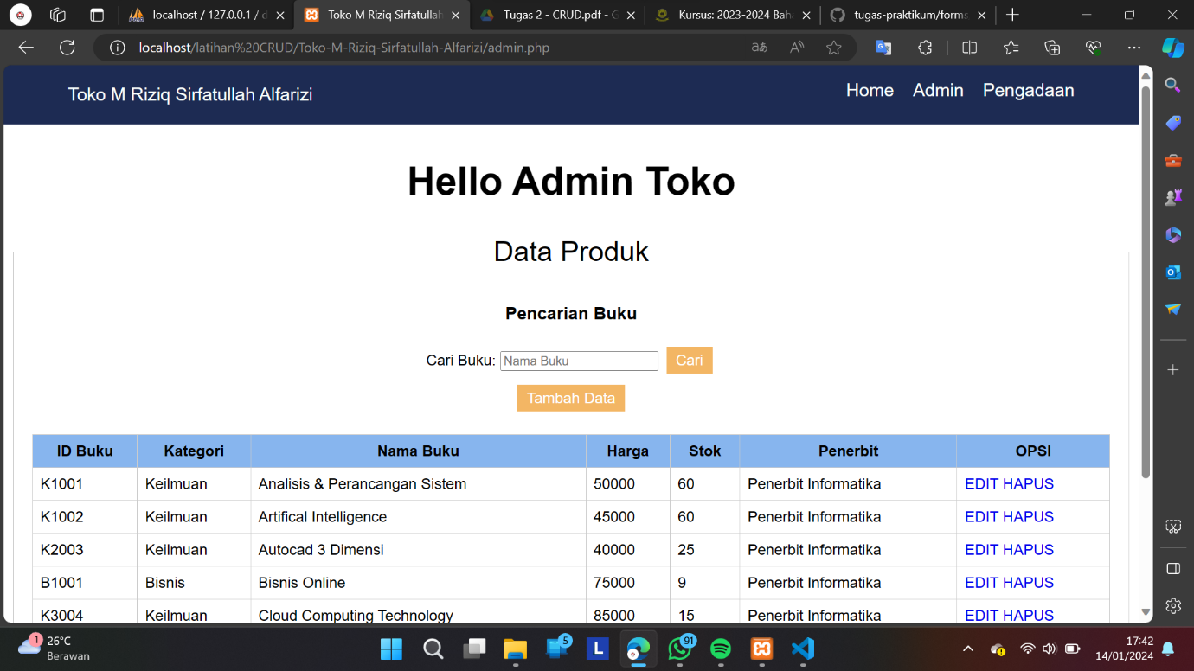

1. Halaman **add_buku_form.php** (Tambah Data)

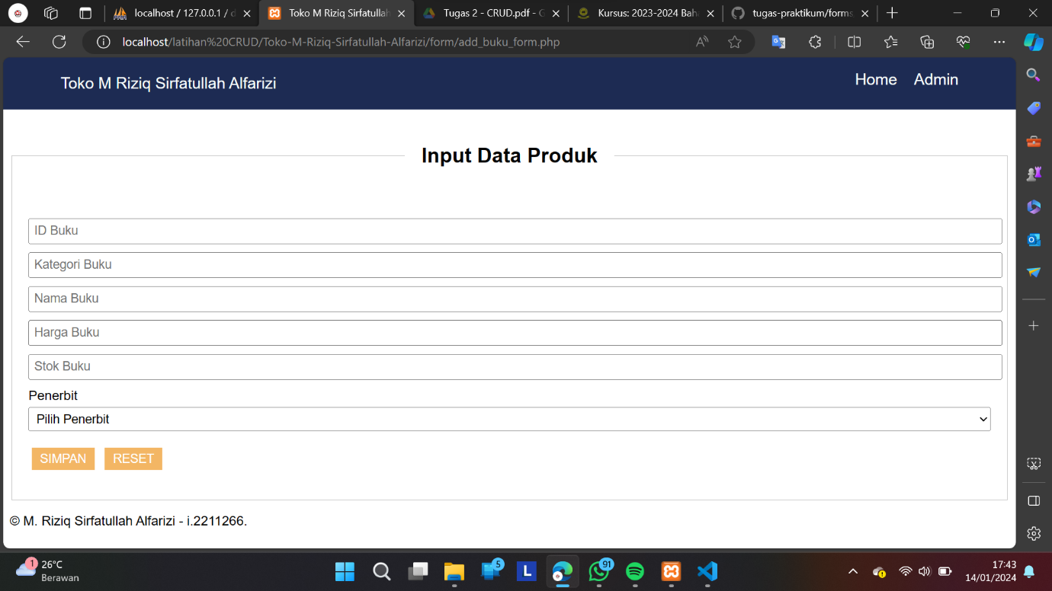

1. Halaman **edit_buku.php** (EDIT)

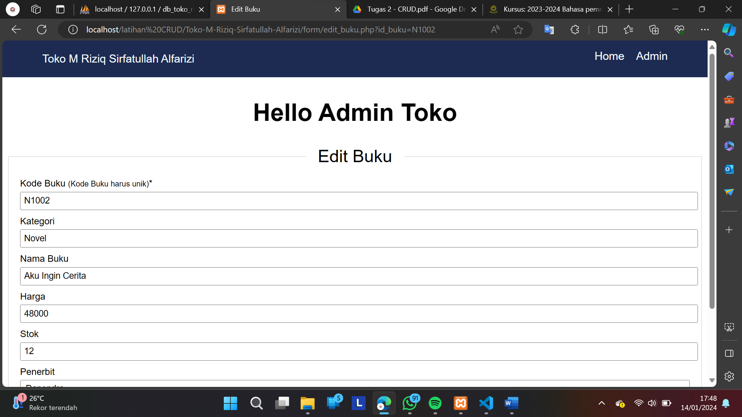

1. Halaman **pengadaan.php**

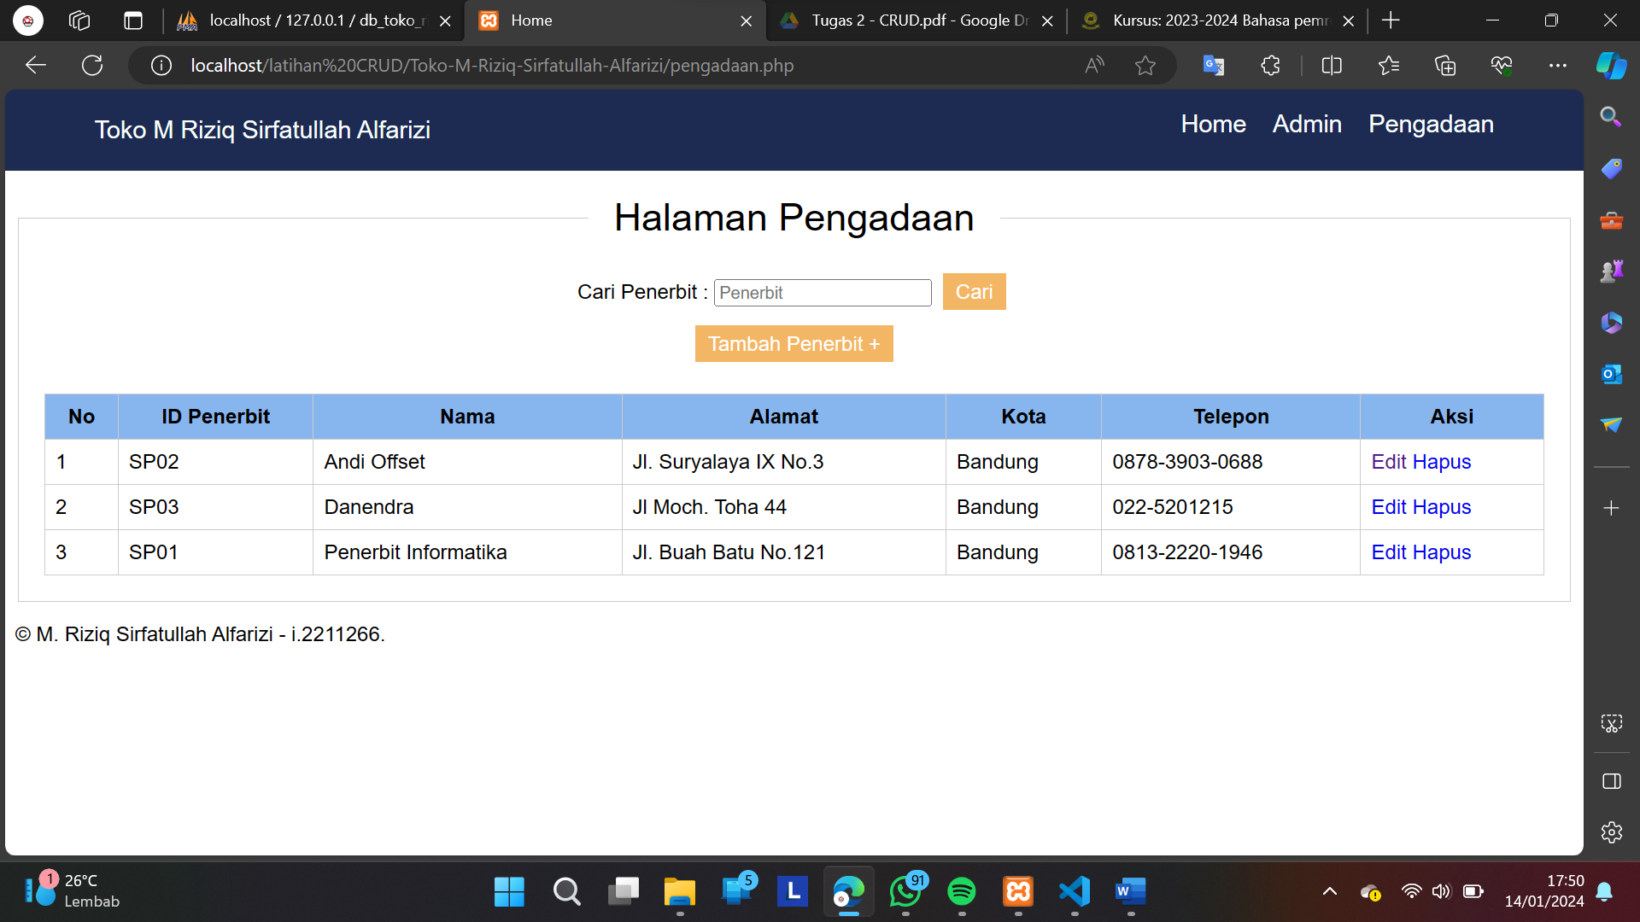

1. Halaman **add_penerbit_form.php** (Tambah Penerbit )

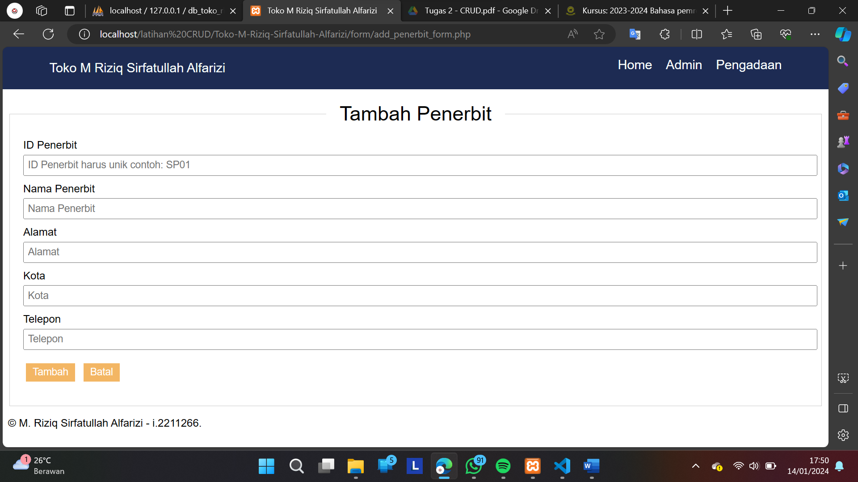

1. Halaman **edit_penerbit.php** (EDIT)

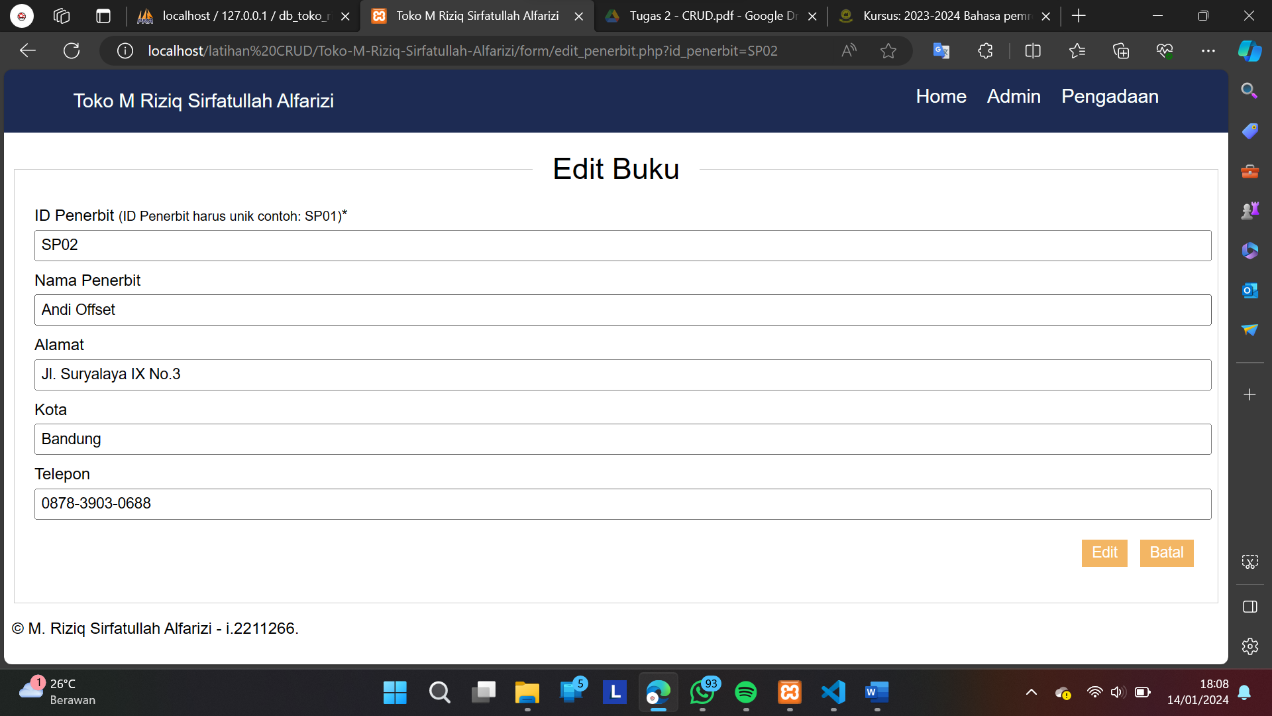

DATABASES (db_toko_riziq)

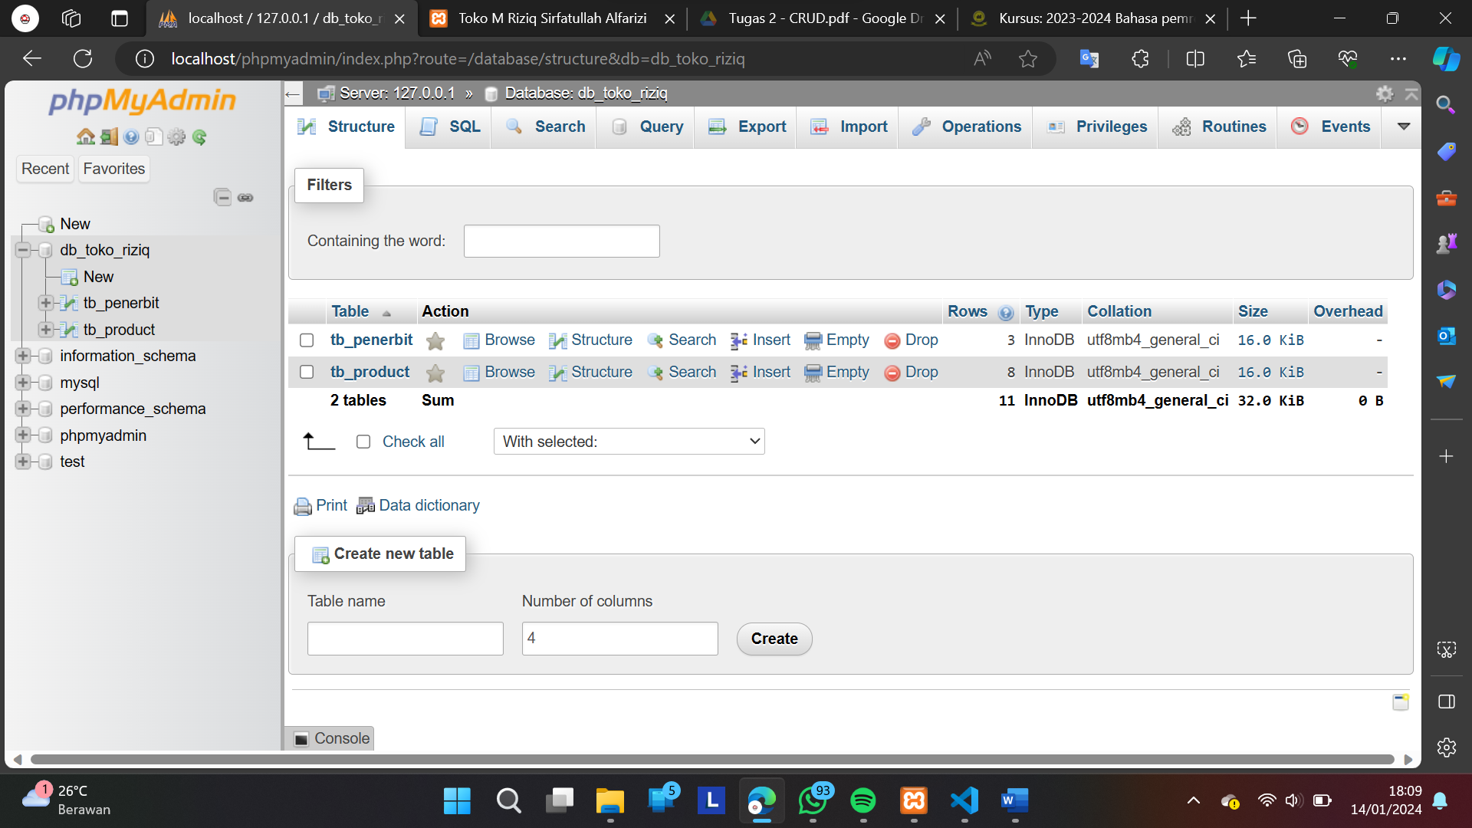

DATABASES (tb_product)

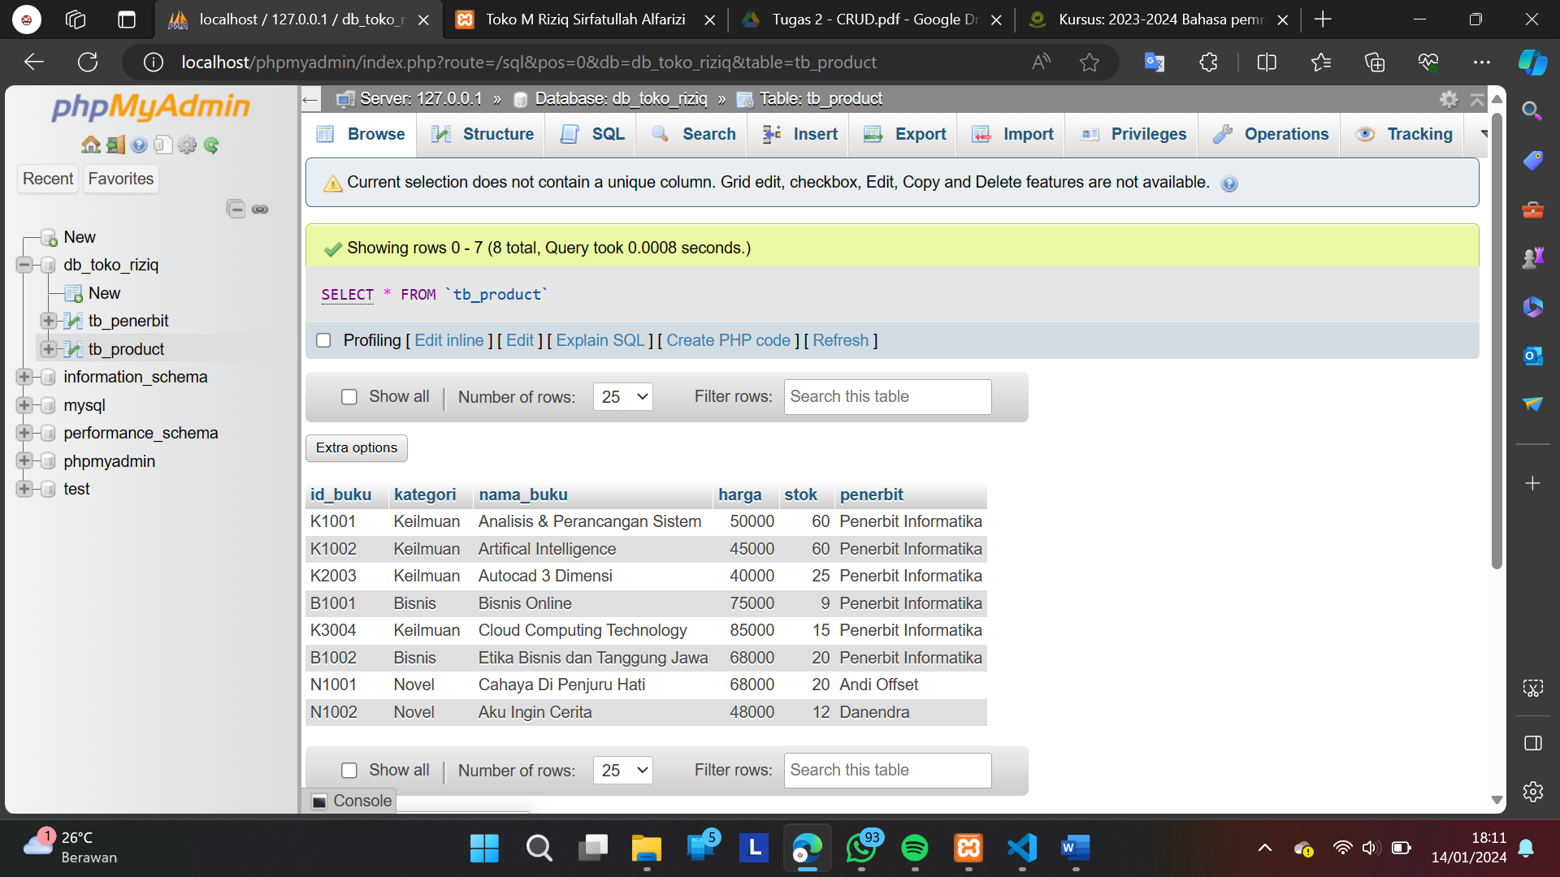

DATABASES (tb_penerbit)

